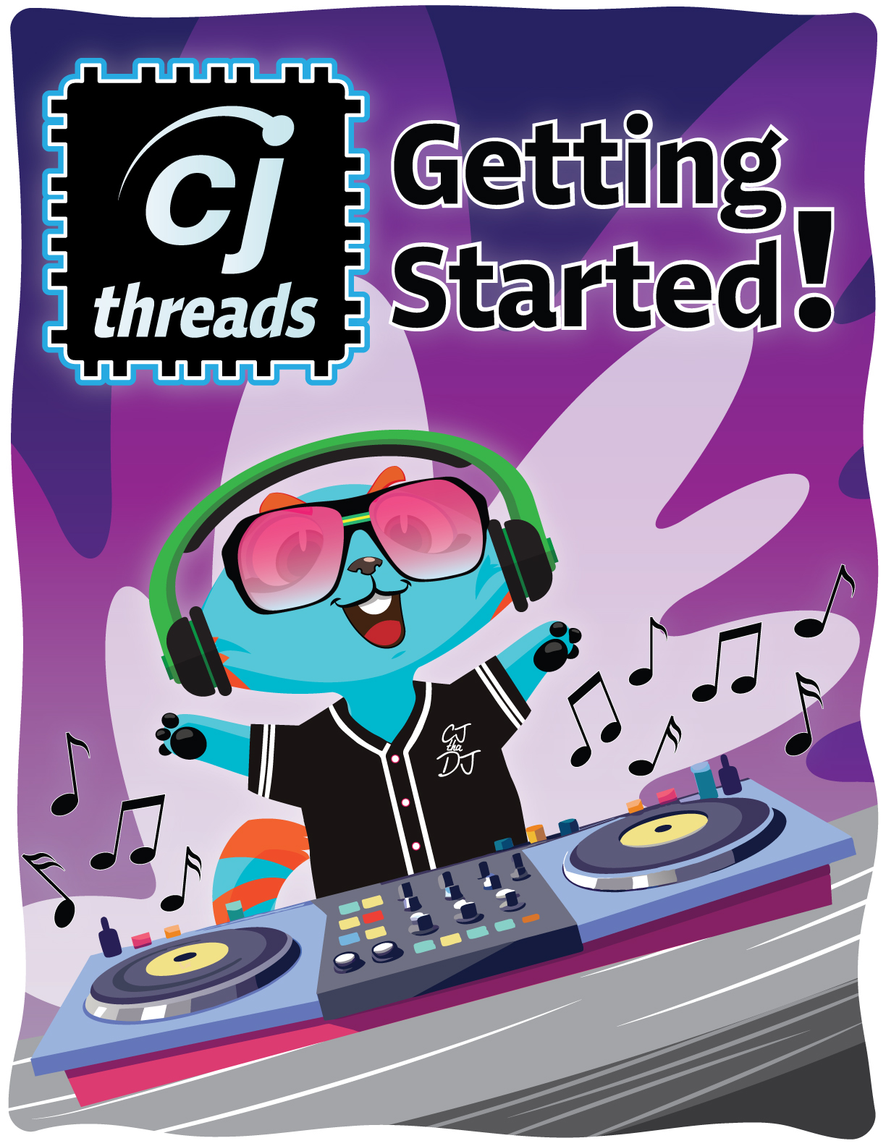

# Getting Started with CJ Threads—Installation Guide

## What is CJ Threads?

CJ Threads is an addition to Code Jumper that introduces students using physical block coding to text-based coding using the Python programming language.

Why is Learning Python Important?   
Python is a programming language that’s super easy to learn and fun to use! Did you know that Python is used to create cool things like video games, websites, and even robots? It’s also one of the most popular programming languages in the world, ranking third after JavaScript and HTML/CSS (Statista, 2024). Python is an excellent first programming language because its code is easy to read and structured similarly to regular written sentences, which makes it simple to understand. Plus, you can use it to bring your ideas to life, whether it’s designing your own game or creating a program that solves puzzles. If you enjoy being creative and solving problems, Python is the perfect place to start!

Materials Needed

* Device with Internet connection
* These instructions
* Video instructions
* Audio peripherals (speakers/headphones)

## Windows Instructions

**Installing Code Jumper with CJ Threads**

If Code Jumper is already installed, check to make sure that the version number is 2.0 or higher. If it is not, you will need to update Code Jumper from the Microsoft Store. If you have not previously installed Code Jumper, it can be downloaded from the Microsoft Store.

Code Jumper can be updated or downloaded by following the link below:

https://apps.microsoft.com/detail/9nxj2dqdqvvg

**Installing CJ Threads Runner**

To install the CJ Threads Runner, download the installation file from https://codejumper.com/cjthreads.php. Once you have downloaded the installer, follow the instructions on the page to install and set up CJ Threads.

## Launching CJ Threads and Code Jumper: Proper Startup Sequence

To use the CJ Threads application, y**ou will have two apps open simultaneously, launching CJ Threads first.**

Launching CJ Threads first will automatically start the Code Jumper app. *If you skip this step and open Code Jumper directly, the application will not function as intended.*

Once the CJ Threads window is open, you can minimize it to keep it out of the way while using the Code Jumper app.

## Reference

Vailshery, L. S. (2024, February 6). *Most used programming* *languages among developers worldwide, as of 2024. Statisa.* https://www.statista.com/statistics/793628/worldwide-developer-survey-most-used-languages/